HILLY FIELDS FOOTBALL CLUB
SEASON 23: 1989-90
FIRST TEAM:
BECKENHAM & CATFORD ALLIANCE:
P W D L F A Pts Pos
Division 17 10 2 5 64 33 22
London Junior Cup 2 0 1 1 2 6
Beckenham Hospital Cup 2 1 0 1 4 4
Tom Betton Invitation 5 4 0 1 11 5
Friendly 3 2 1 0 13 7
TOTAL 29 17 4 8 94 55

Apps Gls Apps Gls
Terry Brown 18 0 Jamie Murray 1 0
Dean Chatfield 2 37 John Newman 4 0
Mick Chatfield 13 0 Stuart Parsley 9 0
Peter Covington 17 0 Paul Quinn 1 0
John Felton 1 0 Mark Rumbelow 28 0
Jim Flood 27 2 Nick Rumbelow 28 3
Steve Ford 23 5 Tommy Salacuri 28 26
Keith Foster 1 0 Charlie Shoppee 12 0
Nick Gayle 2 0 Tom Wilson 8 2
James Greet 22 3 John Wood 24 4
Robert Hare 26 11 Jason 3 0
Dave Keay 16 1
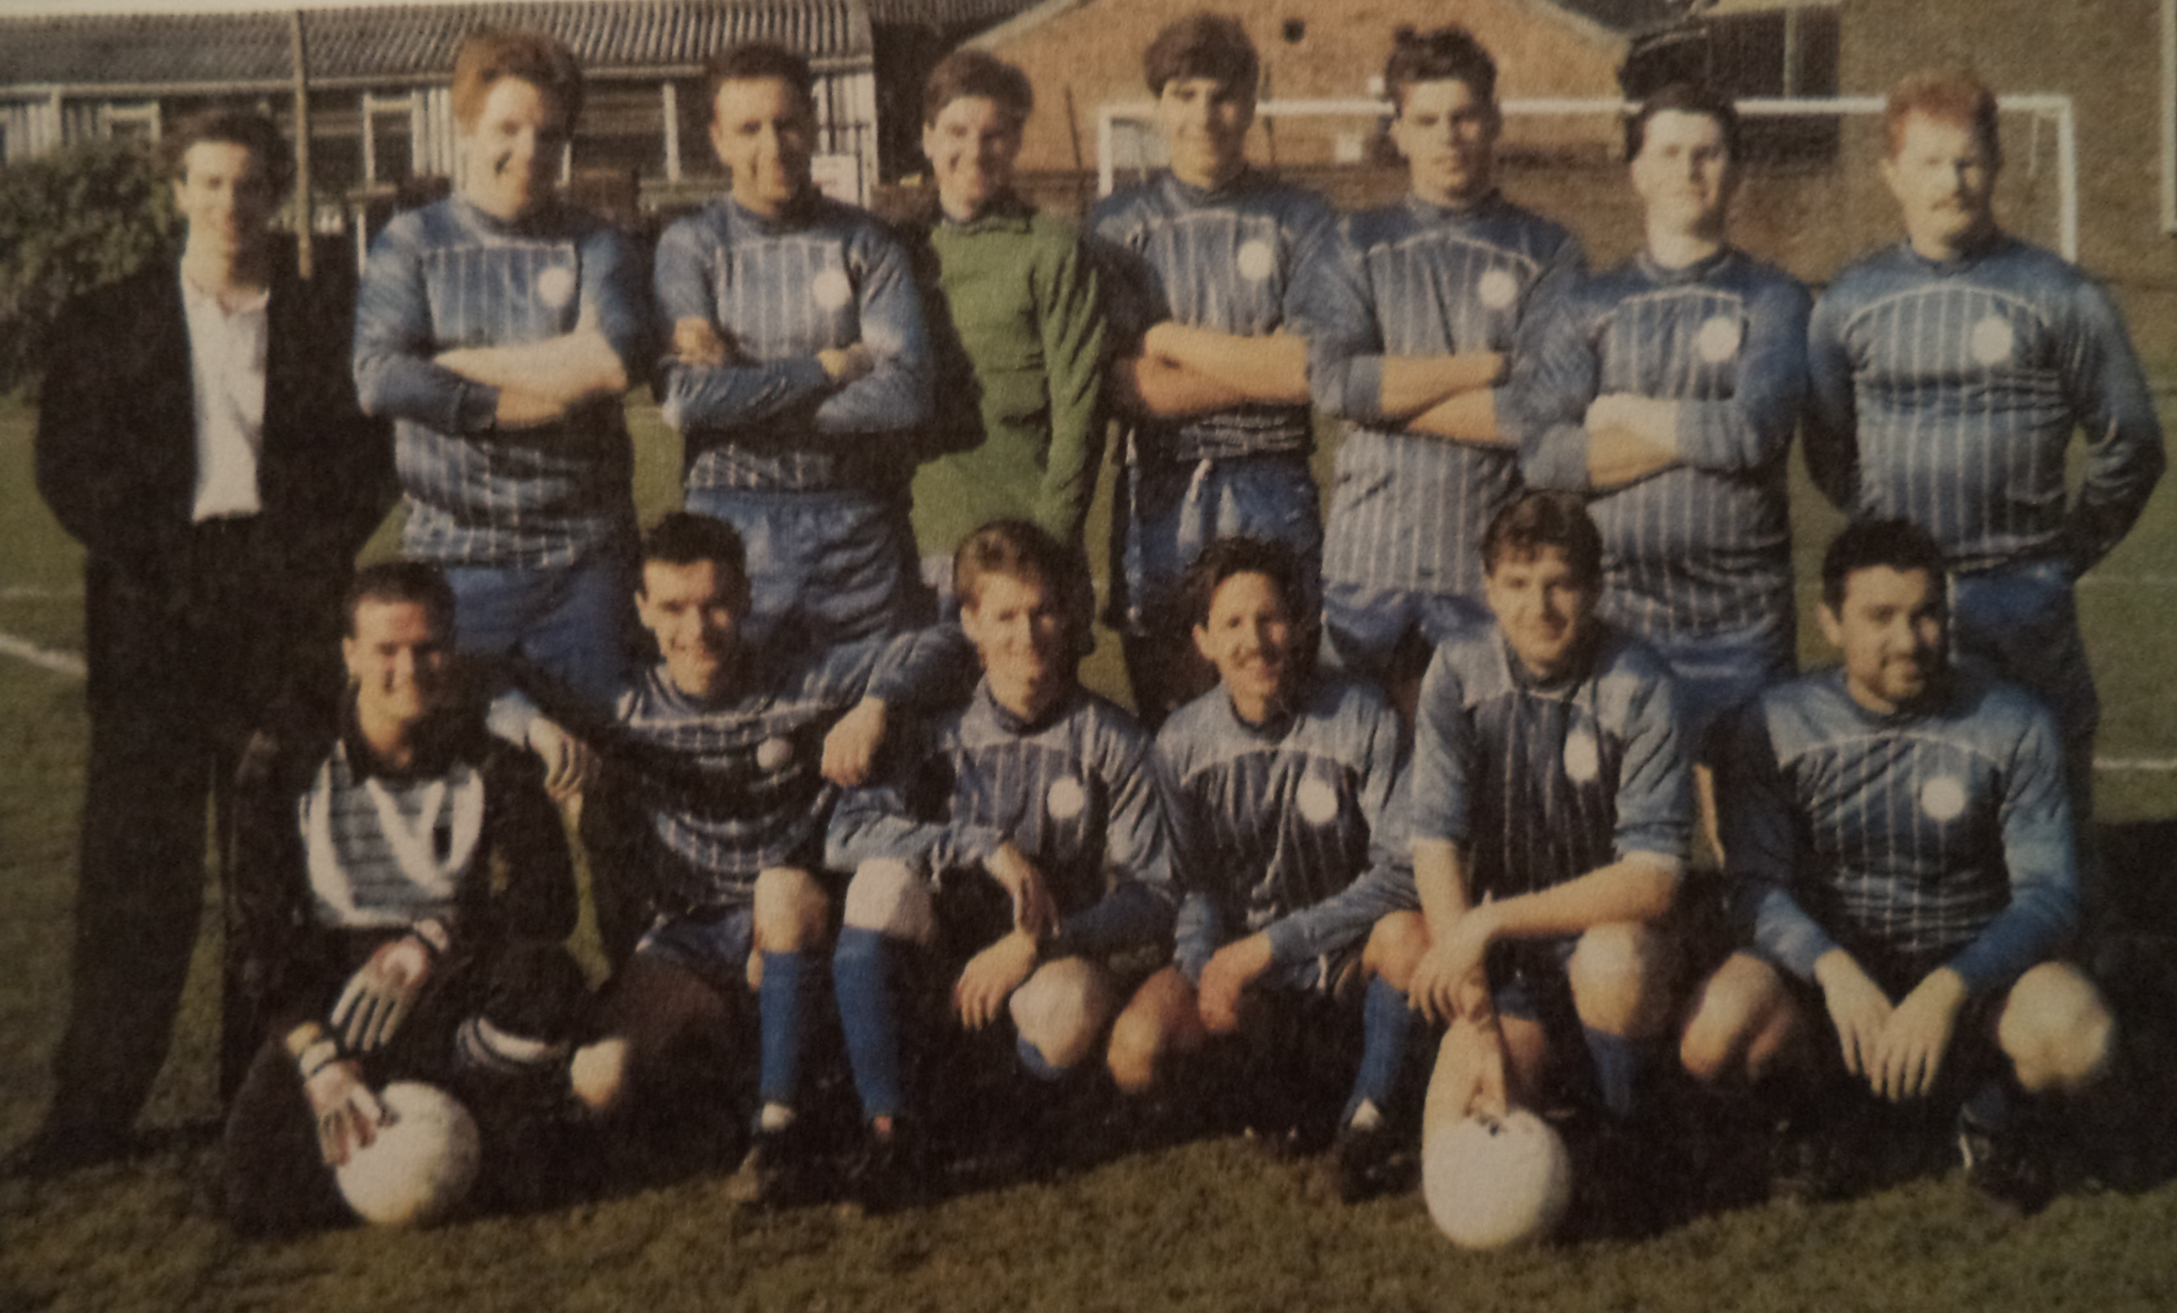
L-R Back: James Greet, Dave Keay, John Wood, Rob Hare, Nick Rumbelow, Mark Rumbelow, Mick Chatfield, Jim Flood,
L-R Front: Terry Brown, Dean Chatfield, Steve Ford, Charlie Shoppee, Peter Covington, Tommy Salacuri

